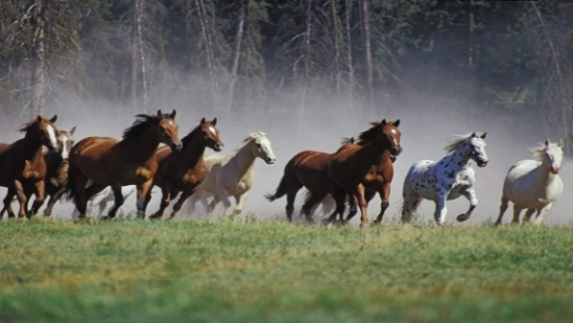

Sulphur Creek Trails 2023-24
AERDA AND THOSE ASSOCIATED WITH SULPHUR CREEK ARE NOT RESPONSIBLE FOR ACCIDENTS, LOSS, OR THEFT. RIDE AT YOUR OWN RISK!
- NEGATIVE COGGINS REQUIRED. PARKING DECAL MUST BE VISIBLE.
- ALL PETS, INCLUDING HORSES, MUST BE KEPT ON A LEASH/LEAD AND UNDER OWNER’S COMPLETE CONTROL.
- STAY OFF/AWAY FROM ADJOINING PROPERTIES, FIELDS, EQUIPMENT, HUNTING STANDS, BLINDS, AND DEER FEEDERS.
- STAY ON DESIGNATED TRAIL & DO NOT MARK YOUR OWN.
- BE COURTEOUS AND RESPECTFUL TO OTHERS.
- ALCOHOL AND GUNS ARE PROHIBITED.
- ANY RULES BROKEN- PERMIT WILL BE REVOKED, NO REFUND GIVEN, AND NEXT YEAR RIDING PRIVILEGES WILL BE SUSPENDED.

**I agree to adhere to the above rules and regulations in order to trail ride on AERDA property…
Signature _______________________________________________________________________
Name ____________________________________________________________________________
Address _________________________________________________________________________
City _______________________ State ____________________ Zip Code _____________
Phone _______________________________ Email ___________________________________
REMEMBER RIDING AT SCT IS A PRIVILEGE NOT A RIGHT.

